GITHUB Document 2
- Install git.
Step 1: Download the installer
- Go to the official Git website: https://git-scm.com/download/win.
- The download for the latest version of Git for Windows should start automatically.
Step 2: Run the installer
- Once the download is complete, open the .exe file.
- If a User Account Control prompt appears, click "Yes" to allow the app to make changes.
Step 3: Follow the installation wizard
- Click "Next" to proceed through the wizard.
- For most users, the default settings are suitable. You can customize options such as the default text editor, the initial branch name ("main" is recommended over "master"), and other components as you go.
- When you reach the "Installation Options" screen, make sure "Use Git from the Windows Command Prompt" is selected.
- Click "Install" and wait for the installation to complete.
Step 4: Verify the installation
- Open the Command Prompt or PowerShell by pressing Windows + R, typing cmd, and pressing Enter.
- Type the following command and press Enter: git --version.
- If the installation was successful, you will see the Git version number printed to the console.
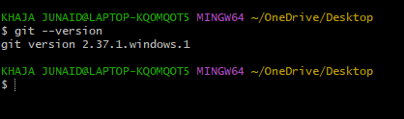

- Create a repo in github with README.md and .ignore file.
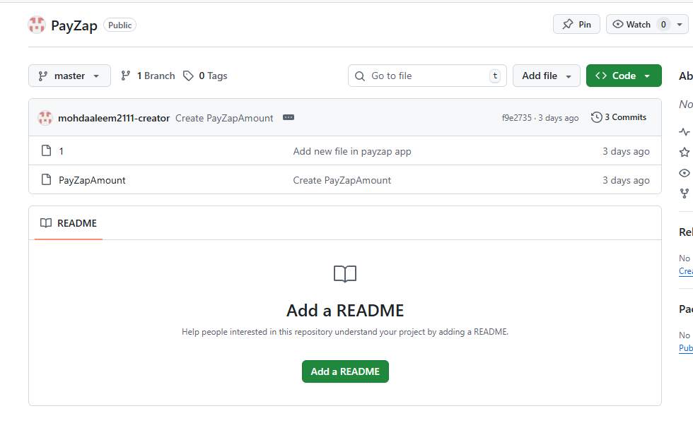
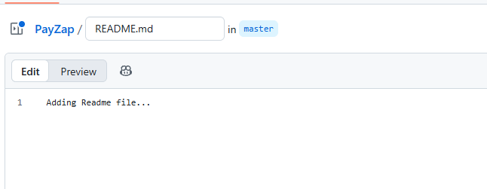
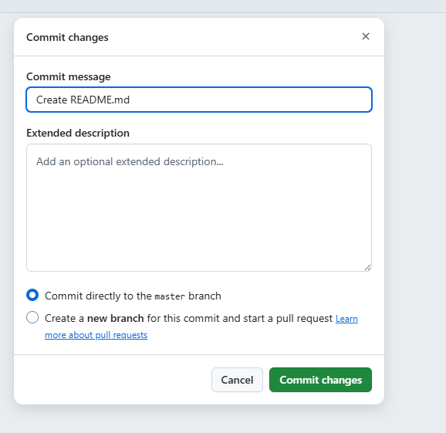
Create gitignore file.
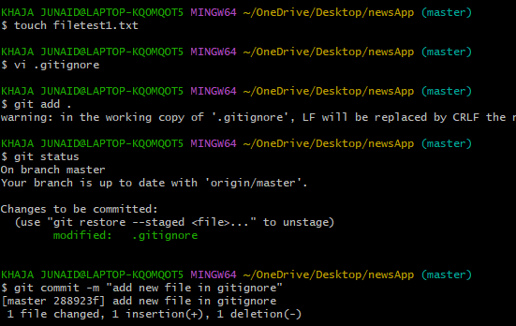
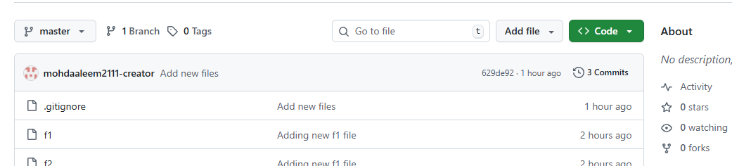

- Clone the created repo to local.

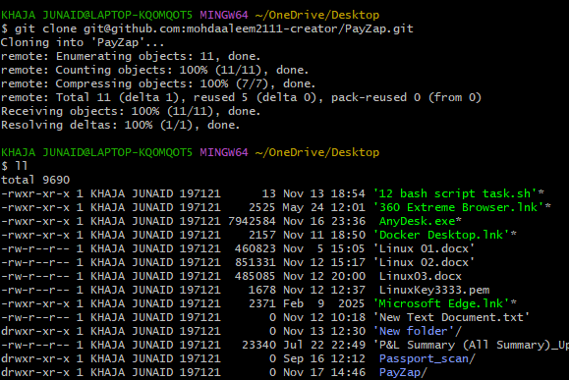
- Create two files in local repo.
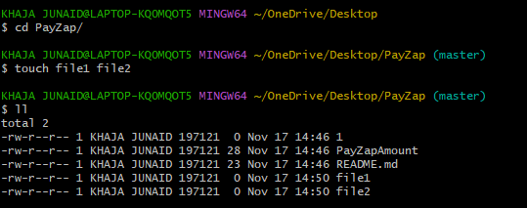

- Commit two files and push to central Repository.
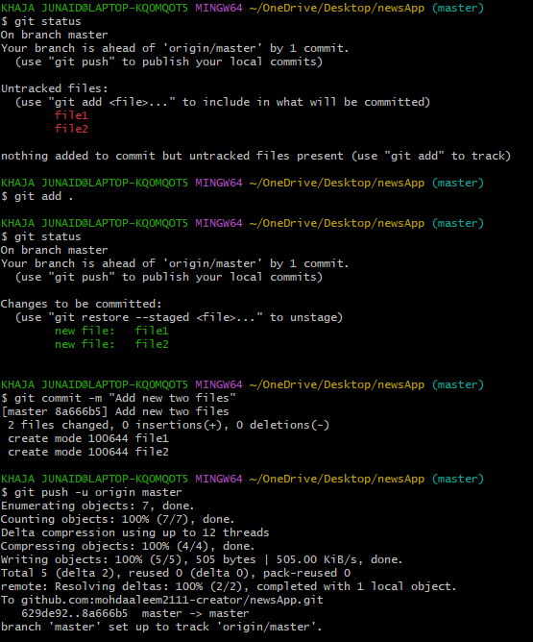

- Create a branch in local and create a sample file and push to central.

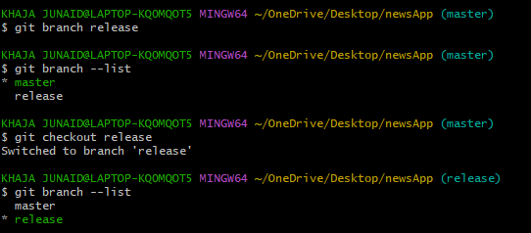
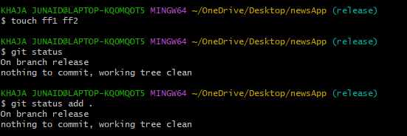


7.Create a branch in github and clone that to local.
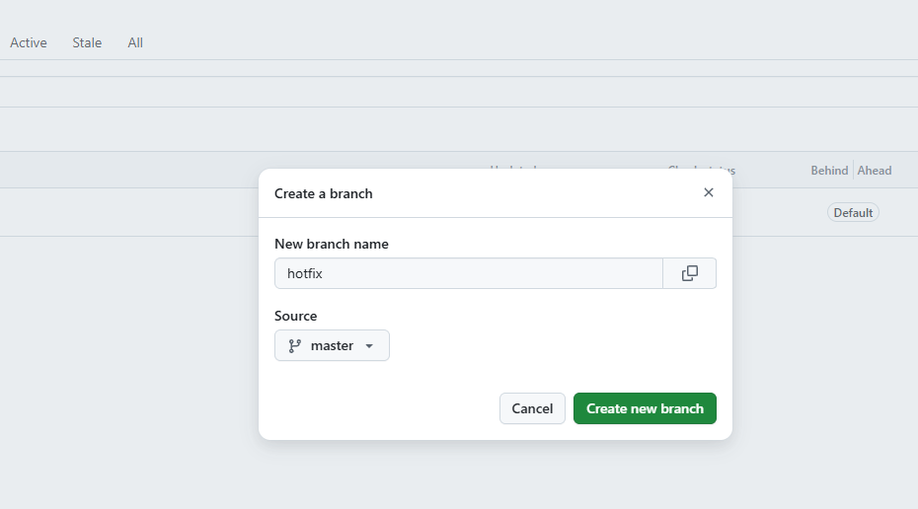
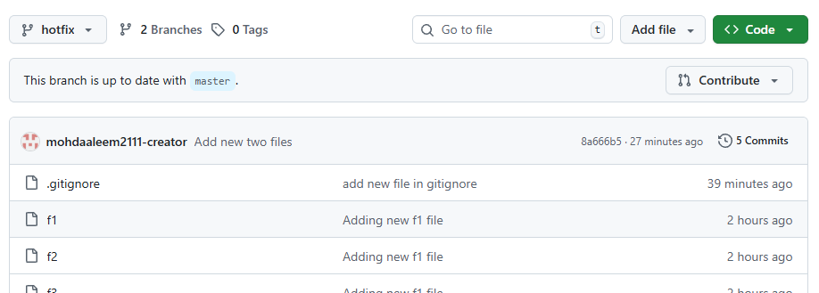
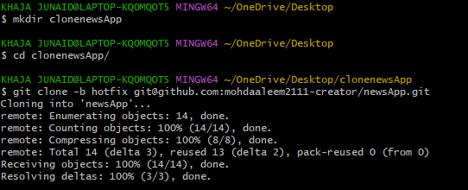

8. Merge the created branch with master in git local.
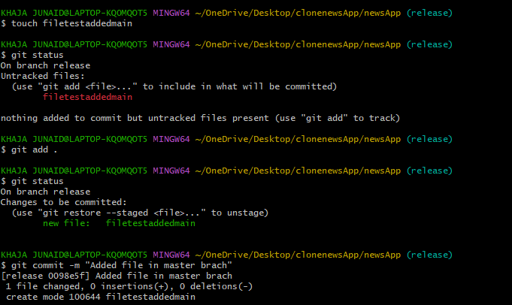
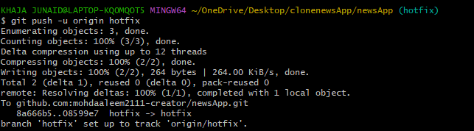
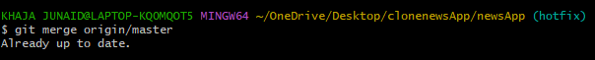
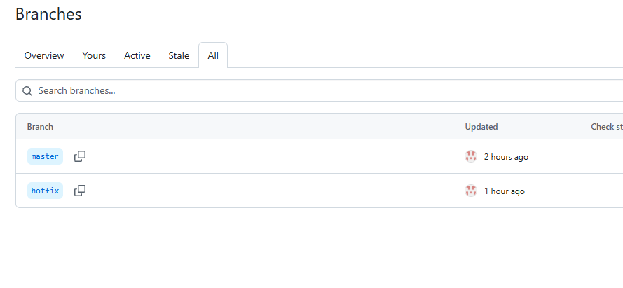

09. Merge the created branch with master in github by sending a pull request.
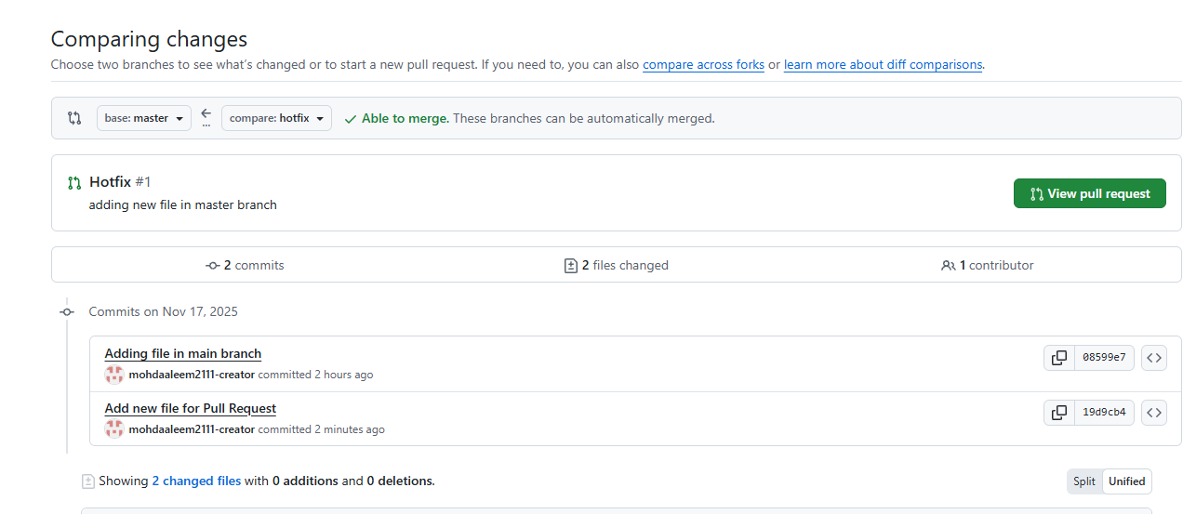
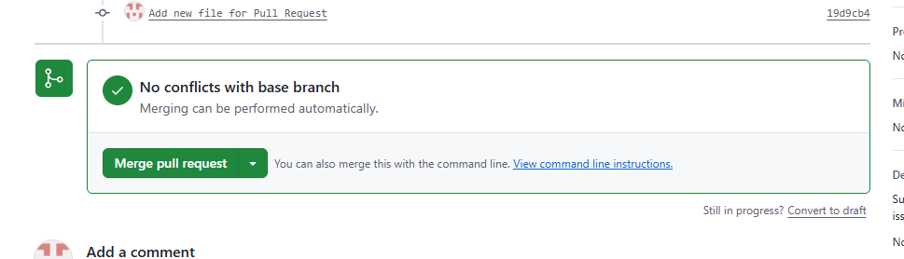
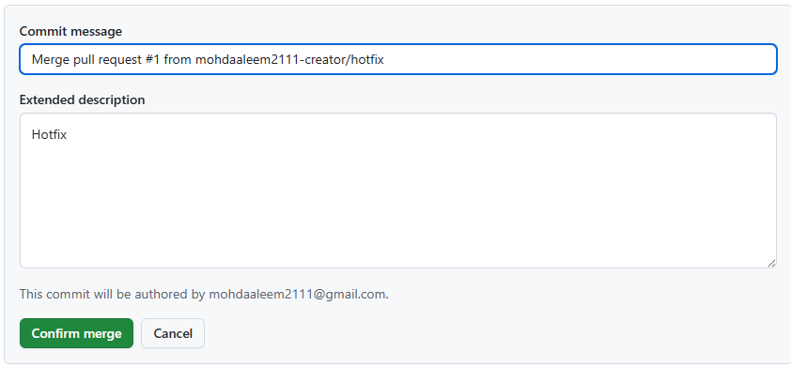

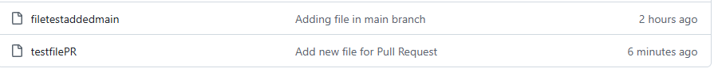

10. Create a file in local and send that to branch in GitHub.
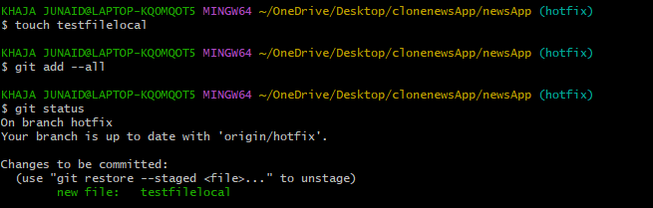
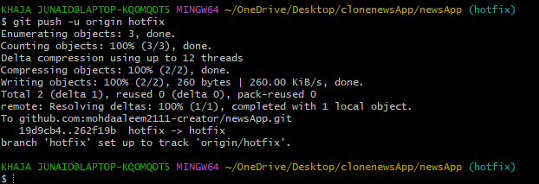
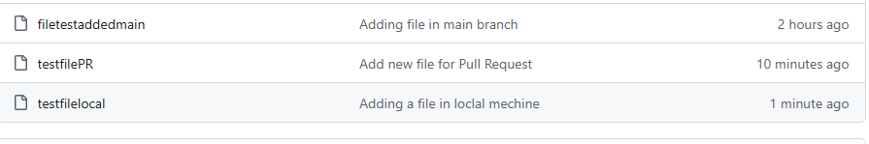

11. Clone only a branch from GitHub to local.
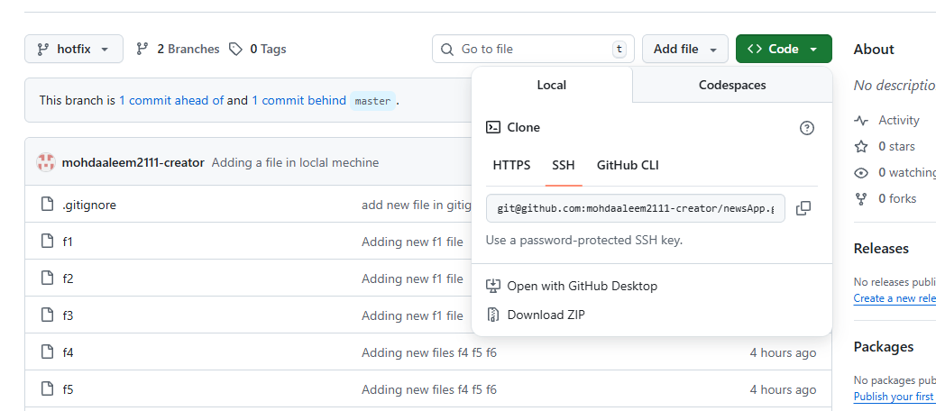
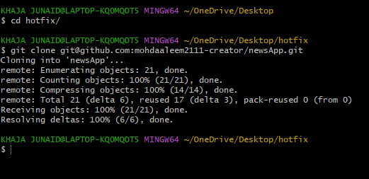

12. Create a file with all passwords and make that untrackable with git.
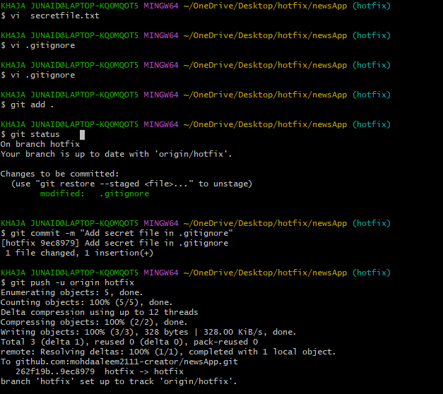
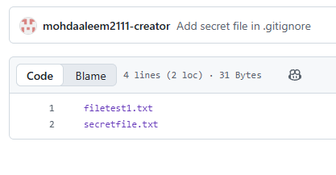
  - Make a commit and make that commit reset without savings changes.

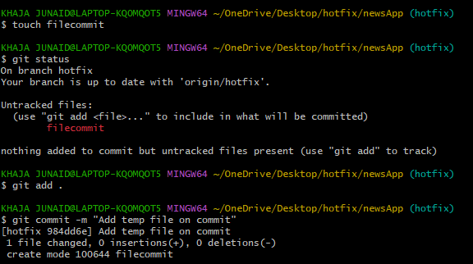
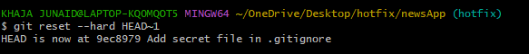

  - Revert a commited commit to the older version.
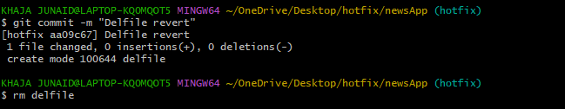
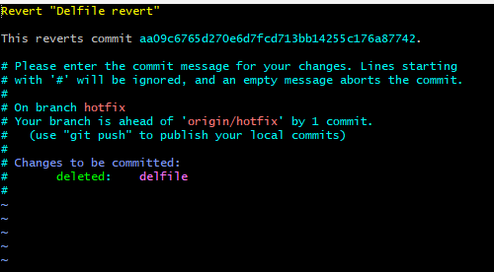
15. Push a file to stash without savings the changes and work on another file.
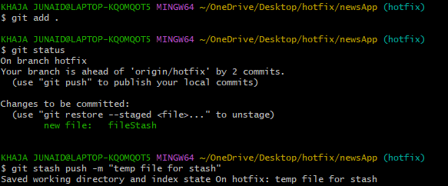

16. Undo the stash file and start working on that again.
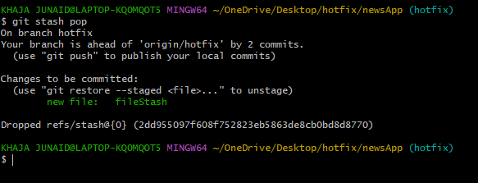

17. Generate a ssh-keygen and configure into github.
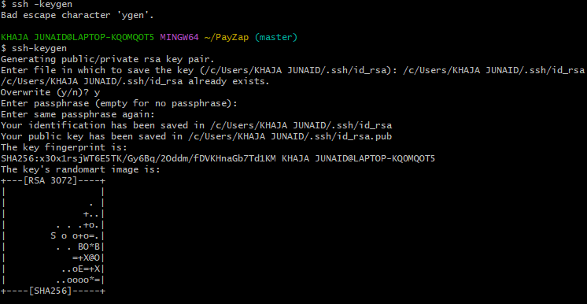
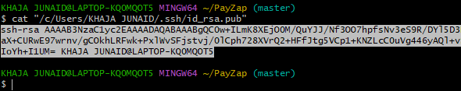
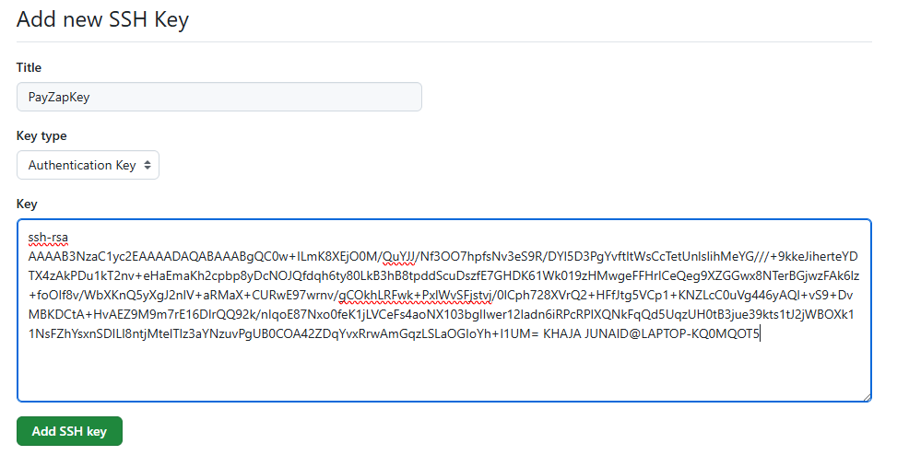
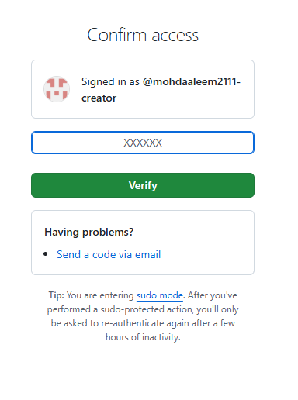
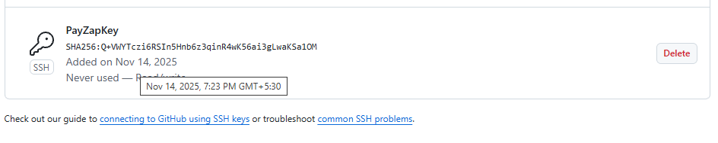

18. Configure webhooks to github.
Skip for now
19. Basic understanding of .git file.
The .git directory is the core of any Git repository. It is a hidden directory located at the root of your project, and it contains all the information Git needs to manage your project's version history.
Here's a basic understanding of its key components:
- HEAD:
This file points to the current branch you are working on. It essentially tells Git where the "head" of your current development line is.
- config:
This file stores the repository's configuration settings, including user information (name, email), remote repository URLs, and various Git options.
- description:
This file provides a short description of the repository, primarily used by GitWeb.
- hooks/:
This directory contains client-side and server-side hook scripts that can be used to automate actions at specific points in the Git workflow (e.g., pre-commit checks, post-receive actions).
- index:
Also known as the "staging area," this file is a binary file that stores information about the files that are about to be committed. When you git add files, their information is added to the index.
- info/:
This directory contains various information about the repository, including an exclude file for ignoring files not managed by .gitignore.
- logs/:
This directory stores logs of various Git operations, such as branch movements and reflog entries.
- objects/:
This is a crucial directory where Git stores all the actual content of your repository, including file versions, commits, trees, and tags, in a highly optimized and compressed format. These are referred to as "Git objects."
- refs/:
This directory stores pointers to commits, specifically for branches and tags. For example, refs/heads/master would point to the latest commit on the master branch, and refs/tags/v1.0 would point to the commit associated with the v1.0 tag.
In essence, the .git directory is the central database for your Git repository, containing all the metadata and historical data that allows Git to perform its version control functions. You should generally avoid directly modifying files within the .git directory unless you have a deep understanding of Git's internal workings. Instead, interact with Git using the git command-line interface or a Git client.
20. Check all the logs of git.
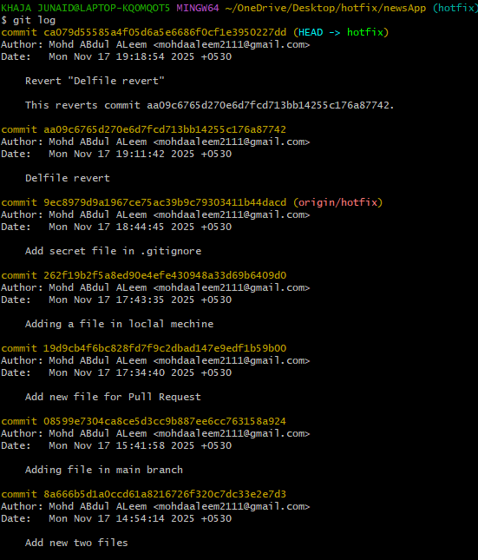
21. Rename the commit message.
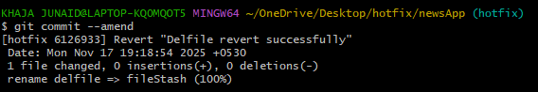

22. Merge multiple commits into single commit.
